Documentation [TDirMonitor]

Properties:

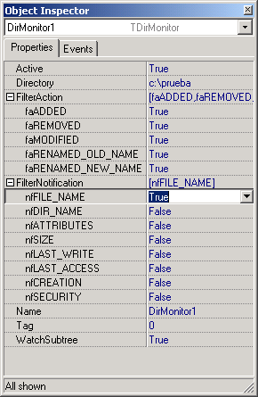
Action filtering, see Table 2
Notification filtering, see Table 1

Watch events for subdirectories.

Events

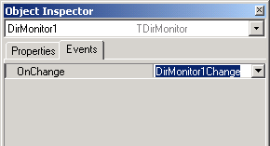
Event

DirMonitor1Change(sender: TObject; Action: TAction; FileName: String);

Sender TDirMonitor itself
Action TAction type, see table 2
FileName Path from base DIRECTORY and file name of which file has been affected

Table 1

Specifies filter criteria the function checks to determine if the wait operation has completed. This parameter can be one or more of the following values:

Value | Meaning
FILE_NOTIFY_CHANGE_FILE_NAME | Any filename change in the watched directory or subtree causes a change notification wait operation to return. Changes include renaming, creating, or deleting a file.
FILE_NOTIFY_CHANGE_DIR_NAME | Any directory-name change in the watched directory or subtree causes a change notification wait operation to return. Changes include creating or deleting a directory.
FILE_NOTIFY_CHANGE_ATTRIBUTES | Any attribute change in the watched directory or subtree causes a change notification wait operation to return
FILE_NOTIFY_CHANGE_SIZE | Any file-size change in the watched directory or subtree causes a change notification wait operation to return. The operating system detects a change in file size only when the file is written to the disk. For operating systems that use extensive caching, detection occurs only when the cache is sufficiently flushed.
FILE_NOTIFY_CHANGE_LAST_WRITE | Any change to the last write-time of files in the watched directory or subtree causes a change notification wait operation to return. The operating system detects a change to the last write-time only when the file is written to the disk. For operating systems that use extensive caching, detection occurs only when the cache is sufficiently flushed.
FILE_NOTIFY_CHANGE_LAST_ACCESS | Any change to the last access time of files in the watched directory or subtree causes a change notification wait operation to return.
FILE_NOTIFY_CHANGE_CREATION | Any change to the creation time of files in the watched directory or subtree causes a change notification wait operation to return
FILE_NOTIFY_CHANGE_SECURITY | Any security-descriptor change in the watched directory or subtree causes a change notification wait operation to return.

Table 2

Value | Meaning
FILE_ACTION_ADDED | The file was added to the directory
FILE_ACTION_REMOVED | The file was removed from the directory
FILE_ACTION_MODIFIED | The file was modified. This can be a change in the time stamp or attributes
FILE_ACTION_RENAMED_OLD_NAME | The file was renamed and this is the old name
FILE_ACTION_RENAMED_NEW_NAME | The file was renamed and this is the new name

.

